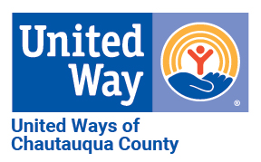
2024 CAMPAIGN REPORT FORM
208 Pine Street, Jamestown, NY 14701
www.uwayscc.org
Phone: 716-483-1561
E-mail: lsunday@uwayscc.org
Please Return Form By: November 26, 2024

Company Name: # of Employees:
Address:
City, State, Zip:
CEO:: Phone: Email:
UW Campaign Contact: Phone: Email:
Return to United Way:
- ALL EMPLOYEE PLEDGE FORMS
- CASH AND/OR CHECK DONATIONS
- THIS FORM COMPLETED AND SIGNED

CORPORATE GIFT | Please enclose the signed Corporate Pledge Card  - Bill Monthly  - Bill Quarterly  - Bill Once on :______________________ (date) |  |  | $______________
EMPLOYEE GIFTS | Instructions | Number of Givers | Total 2024 Pledge/Donation Amount
1) Cash | Include original employee pledge forms, copies of pledge forms, or a spreadsheet summarizing employee pledges.  Leadership Circle and Emerging Leader donations should be noted on the pledge form. |  | $
2) Checks |  |  | $
3) Credit Card |  |  | $
4) Bill Me |  |  | $ | If you would like to receive this bill electronically, please indicate an email address here:
5) Payroll Deduction | - Bill Monthly  - Bill Quarterly  - No Billing Required |  | $
Additional Notes
Total Employee Gifts | Please total rows 1-5 above.  All pledge cards must be signed by donors. |  | $  (Employee Gifts) | $  (Corporate Gift)
Authorized Signature: Date: ________________________

